Lecture 18: Institutions and Economic Development

Professor Raj Chetty

# Introduction to Developmental Economics

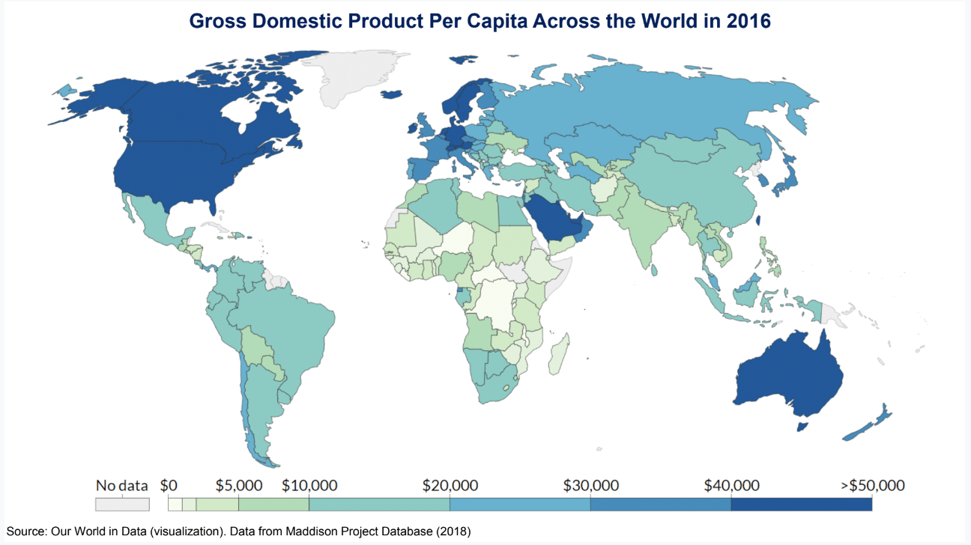

* There is a tremendous range in terms of incomes per capita across the world where countries like the United States and Western European countries have GDP per capita of $50,000 or higher, and countries in parts of Sub-Saharan Africa have GDP per capita that is ten times lower. That broad variation has attracted enormous attention from many different fields over decades, and we will discuss how economists think about improving outcomes in developing countries which is the field of development economics.
* Development Economics differs from more traditional work in economics because there are important differences in technologies in developing nations.
  + For instance, the technology available to enforce the tax system in developing countries is often very different than the type of enforcement technologies and records in the US. That leads down a different path in terms of the types of questions we can ask and the types of policies that are feasible. Developing countries also have different institutions, and changing institutions themselves can be an important part of the of the puzzle in terms of figuring out how to affect outcomes.
* There are two types of approaches in modern development economics.
  + The first is simple policy evaluation. The second is a macroeconomic approach stepping back a bit rather than thinking about particular education, health, or technology policies, and thinking more about improving basic institutions and the structure of government.
* Starting with the policy evaluation approach, there is a huge field now in development economics that evaluates policies largely through randomized experiments many of which have been fueled by the Poverty Action Lab that Esther Duflo and her collaborators founded at MIT.

# Deworming the World

* A second example of such a policy that has had a substantial impact was deworming children. Intestinal worms affect 25% of the world's population, and worm infections can affect educational achievement.
* There has been concern among people in the health literature about how to reduce the prevalence of worm infections.
  + Ted Miguel and Michael Kremer come at this question from more of a social science angle asking how to effectively reduce the rate of worm infections through public policy on a large scale. They study the impact of a deworming treatment through simple pills on health and education outcomes in Kenya.
* The most intuitive thing that we may think of if we want to study the impacts of this pill is just a randomized treatment at the individual level.
  + For example, we could take children in Kenya and randomly give some of them this deworming treatment and not give it to others, compare treatment and control, and look at various outcomes.
* That approach, while it would be a sensible thing to start with, potentially underestimates the impact of the benefit of the treatment at a social level for two reasons, both of which relate to the fact that worm infections are contagious. Suppose I just gave the pill to half the people in a class and not the other half, there are actually going to be benefits to the people on the untreated side because they are less likely to get this infection because the people who got the treatment themselves have lower probabilities of getting infection. This is related to the idea of herd immunity and contagion. There is a positive externality here of getting treated. That is one reason a simple randomized experiment would underestimate the impacts.
* Second, if we think about the treatment control design that we are using where we are comparing kids who are in the same class, we are furthermore going to underestimate the causal effect for the treatment group itself because the control group is benefiting, and so the benchmark that we are comparing the treated kids to is itself changing, which leads to understating the extent to which the treatment group benefited from the treatment. This is known as contamination of the control group.
* The way Miguel and Kramer solved this problem is by evaluating an intervention that was randomized at the level of schools rather than individual kids. This captures the externalities across kids within the same school, which is presumably how worms would spread.
  + Specifically, they took 75 schools in Busia, Kenya and randomly divided them into three groups. The schools in the first group got the deworming treatment in 1998 and 1999. The schools in the second group got it in 1999, and the schools and the third group—which serves as a control—got the treatment in 2001. It is just a straight, randomized comparison of the schools that got the treatment earlier versus later.
* Comparing group two which was a control group in 1999 with group one who had already begun to be treated, we see reduction of infection by 25% points, consistent with medical literature. Importantly, what they talk about in the paper is that the effect is twice as large as what we would estimate if we just did this at the individual level, and that is because an individual level experiment cannot capture the spreading externality benefits.

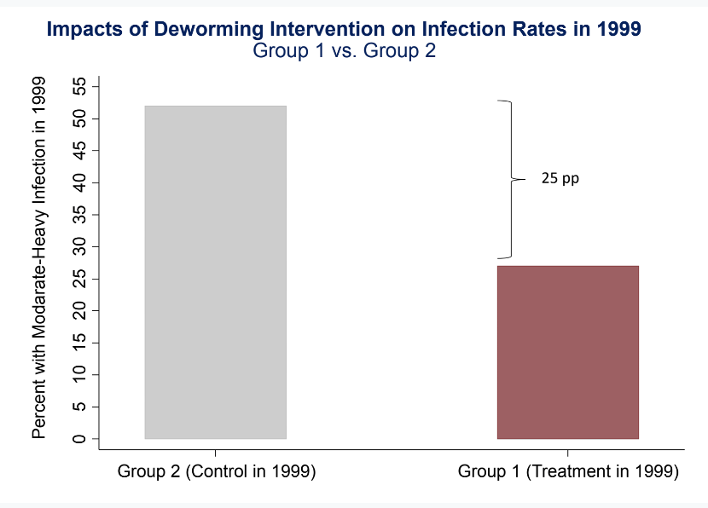

* Then they ask if the deworming treatment has longer term benefits. In a more recent study, Ted Miguel and Michael Kremer, with their co-authors, measured the impacts of the program on outcomes a decade after this initial intervention that they had conducted.
* They followed the children over a 10-year period. These children are now in their early 20s. Remarkably, for a developing country setting, this is not a place where we can use tax records and Social Security Numbers, and follow everybody over time automatically, they actually had to survey people which is quite expensive and complicated.
  + Despite that challenge, they managed to track 83% of the kids from the point of the initial intervention to when they are looking at these outcomes.
* It is slightly trickier in thinking about the statistical analysis because all schools have been treated, so there is no pure control group.
* Instead, the way they do the analysis is by comparing *treatment intensity*.
  + They compare different groups of schools like group 1 versus group 3 that had different durations of the anti-worm medication.
  + Groups one and two, because they got the treatment about two years earlier, received about two and a half more years of exposure to lower rate of worm infections than group three. Treatment now refers to the schools that got the treatment earlier, groups one and two, the extra two and a half years. Control, it is not a pure control, is the schools that got the treatment later.
* They start by looking at impacts on self-reported health between 2007 and 2009, 10 years after the 1999 point of intervention, and people in the treatment group are reporting somewhat higher rates of being in good health than people in the control group. There are persistent gains in self-reported health.
* The rates of miscarriage among pregnant women drops quite substantially from 4% in the control down to 1.1% in treated group.
* Then turning to educational and economic outcomes going beyond the health outcomes, they look at impacts on educational attainment, and the control group had about 6.7 years of schooling on average.
  + The treated group had closer to 7 years of schooling, and that difference of 0.3 years is statistically significant. We are seeing significant gains in terms of the amount of education because of these deworming treatments early on. Commensurate to that, they also find significant increases in the amount that people are earning, years later, close to a 30% increase in earnings as a result of a two and a half year extra deworming treatment.
* Does this seem like a good treatment? Is this a good approach to trying improving outcomes? The way to answer this, as economists usually do, is to think about it from a cost-benefit perspective. Where do we have the most bang for the buck for various policies we might implement?
  + In this particular case, the average per person cost of the deworming treatment when they implemented it was about $1 per child. The average benefits based on their analysis are quite large. For every child we treat, the number of years of education increases by about 0.12 years, and total earnings over the person's life increased by about $140 in the Kenyan setting.
  + The $140 is large relative to the $1 cost, and so we can then ask if this seems like a cost-effective program? The simple logic is just comparing $140 to the $1, and this seems cost-effective. A different way that we can look at this is just from the government's perspective itself, the program is actually going to pay for itself because if we spend a dollar upfront, and we have this additional $140 that people are going to earn, we are going to tax that in various forms down the road. What they show is the additional tax revenue is going to more than offset—by a factor of 10—the $1 of initial expenditure. The government is actually going to make money in the long run through this deworming intervention.
* Moreover, we can do a similar cost-benefit analysis for various other types of programs that try to improve long-term outcomes, and we can see that the cost effectiveness of this deworming intervention is extremely high compared to many other interventions that people have studied over the years. There are things like scholarships or conditional cash transfers that give individuals money if their kids attend schools, or providing uniforms, other types of informational interventions, monitoring, teachers, etc.

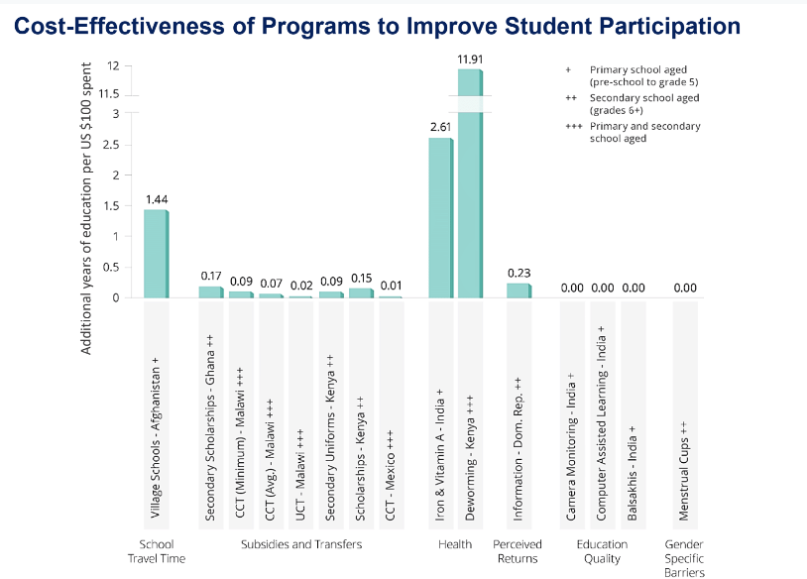

* The treatment with the highest impact is this deworming intervention where they see an 11.9 year impact on years of education per $100 spent. As a result of that, in light of this evidence, this has led to a tremendous scaling up of this sort of policy. This approach has now been scaled to over 285 million kids in 2017. That is been done in particular by an organization called Evidence Action that has formed what they call the Deworm the World Initiative which was on the basis of this evidence trying to do this on a mass scale.

# Institutions

* A potential critique of the policy evaluation approach is that it is difficult to test and improve every single policy that countries might implement. That is especially the case when the types of policy challenges a country may face will change over time.
* This motivates a different approach, a more macroeconomic or institutional approach where we try to improve the efficacy of governments and institutions so that countries are on a better by themselves without thinking about every single policy implemented. The big-picture aspiration would be to try to equip countries to figure out how to improve things like sanitation, public health efforts, expand schools, etc., by themselves.
* This is clearly a more scalable approach if we can figure out how to do it. It is also much more difficult to implement. For a long time, economists have thought that institutions might be important.
  + Most famously, there is theoretical work by Douglas North—a famous economist who won the Nobel Prize for this research—arguing that strong institutions are central for economic development. His thesis was that what really drives differences in economic outcomes across countries was not what people were talking about traditionally like differences in natural resources, or climate, but fundamentally, things like institutions.
  + The countries that were really productive and high income had better institutions. People were interested in testing that hypothesis and trying to figure out which types of institutions are in fact most effective in improving long-term outcomes.
* Recent work in this literature takes a big data approach and focuses on sub-national differences in institutions in a very precise way, in order to analyze their long-term impacts. The method that is going to be used here is essentially historical data analysis showing how economic historians in very creative ways go back in time to recover information about things that were happening in the past, and then apply modern empirical techniques to tackle challenging problems like trying to figure out the causal effects of institutions.
* The paper presented here is by Melissa Dell, who has really pioneered this type of research. In one of her papers, she focuses on Peru, and on an institution called the mining mita. She presents evidence on the long-term impacts of institutions by studying the persistent impacts of Peru's mining mita.
  + The mining mita was a system instituted by the Spanish government when they had colonized Peru in 1573, and it was later abolished in 1812. It required a large group of communities that were near two of the largest mines in Peru to send 1/7th of their adult male population every year to work in the mines. The way they did this had a very specific feature which is what Melissa exploits in her study.
  + The Spanish government could not have people commuting very long distances to get to the mine, so they drew a boundary around these mines, and all of the communities that were within that boundary were part of this mining mita system. They had to send 1/7th of their men to work in these mines.
* If they were just outside the boundary, they were exempt from the system. This sharp break lends itself to a spatial regression discontinuity design where we can compare outcomes in places that were just inside the boundary that were subject to the mining mita to places that were just outside the boundary.
  + We must be careful when doing this analysis geographically because some of the places may be geographically distinct, like on the side of a mountain, compared to plains inside the boundary. We may see very different outcomes between those two places because they are different economies.
  + That is not a good regression discontinuity because there are other things changing right at the border—in particular elevation—which might affect economic outcomes in various ways.
* Recognizing that this is the case, Dell hones in on two sets of areas which she argues have very similar economic conditions before the mita system went into effect. She collects data from district capitals inside and outside this region in order to study the long-term impacts of the mita on institutional development and ultimately on economic outcomes.
* She starts with a simple measure that people use to think about economic outcomes in developing countries which is children’s heights.
* A simple way to measure nutritional outcomes in a setting with a lot of poverty and malnutrition is just the height of kids. If there is a lot of malnutrition, we observe stunting, which is defined as having a height that is two standard deviations below what is expected for a given age.
  + This is useful because governments tend to have data on kids’ heights in a very systematic way for large samples. The take home message is very clear. The rate of stunting in the present-day—well after the Mita Institution itself had ended—changes very sharply at the boundary, and the fraction of kids who are stunted falls by 30%. This institution that was set up in the 1500s is continuing to have lasting effects centuries later.
* There is a similar pattern for metrics like household consumption, literacy, etc. Melissa Dell argues in her paper that this is happening because non-mita areas had very different institutions.
  + In particular, they had a system of land ownership and property rights that was set up historically and persists to the present day, whereas the mita areas did not have a clear system of property rights and after the system ended, no real system emerged there for people to say have established property rights.
  + As a consequence, she argues, there are many more large rural estates which provided employment opportunities and potentially, these large landowners advocated for public goods like roads and education outside the mita boundaries in a way that did not happen within these boundaries. To show this, she looks at measures of public goods provision like the density of roads which is much higher outside the boundaries than inside.
* Dell argues that the mita system had substantial adverse impacts on economic outcomes. Long-term outcomes look extremely different as a result of these borders. She argues that is because of a 3-step process that led to a change in institutions.
  + First, there was a negative impact on property rights and land ownership.
  + Second, that led to an impact on public goods provision. In particular, large property owners have power to advocate for public goods like roads. She shows evidence in the paper that the way the roads were set up outside the mita areas, they ran exactly next to these large farms providing evidence that these were large landowners trying to get resources to construct these roads.
  + Third, the disparity in public goods significantly changed the structure of markets and changed economic productivity. Even today, the residents of the areas subjected to the mining mita are much more likely to be subsistence farmers because of a lack of access to roads, to markets, to human capital.
* The argument is that this basic institution that led to changes in the structure of property rights has these dramatic effects on economic development that we can trace out very clearly. Independent of any specific policies that we may be trying to change, setting up better institutions—like better property rights—could potentially have quite substantial long-term impacts.